Deliverables for Milestone 1

Use Cases Description 1

Use Case Diagram 2

User Stories 2

List of Functional and Non-Functional Requirements 3

CRC Cards for User Stories 3

UI Mockups 4

# Use Cases Description

**A user browses the catalogue (whether logged in or not)**

The user visits the web platform.

The system shows products.

The user can view detailed product information.

The user can add the product into the cart but for the checkout is required to register or login.

**An unregistered user register on the web platform**

The user clicks the registration button.

The system requires the input of username/email and password.

The user enters username/email and password.

The system checks the entries:

* if the username/email already exists, show a warning, and stay on the same page.
* If the password does not match the strength criteria, show a warning, and stay on the same page.
* if an information is missing, show a warning and stay on the same page.
* If all the information is successfully inserted, continue to the next step.

The system requires the input of additional information.

The user enters additional information.

The system saves the user input and creates a new user.

The system shows the successful registration popup and redirects the page to the profile.

**A registered user login to the web platform**

The user clicks the login button.

The system requires the input of username/email and password.

The user enters his/her login credentials.

The system checks the entries:

* if username/email or password is invalid, show a warning and stay on the same page
* if username/email and password are entered correctly, the system changes the status of the user to logged in and redirects to the last visited page before clicking on the “Login” button.

The user can click on “Forgot password” if needed.

After clicking on the “Forgot password” button, he/she will receive an email with instructions how to reset the password.

# Use Case Diagram

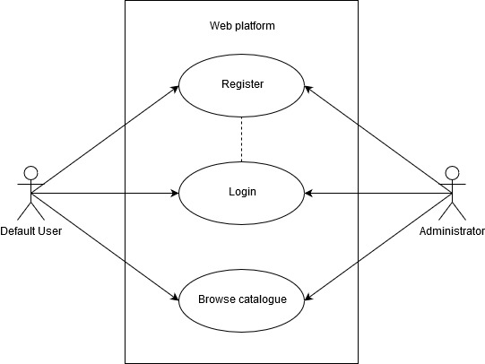

https://www.diagrammeditor.de

# User Stories

As an unregistered user, I want to register, so I can login to the web platform.

As a registered user, I want to log in, so I can make full use of the web platform.

As an unregistered user, I want to browse the catalogue, so that I can see the products before I must register.

As a registered user, I want to buy and sell products.

As an administrator, I want to approve/disapprove product ads added by users, before pushing the ads live.

# List of Functional and Non-Functional Requirements

**Functional:**

Register a new user

Login a registered user

Browse the catalogue

Sell and buy products

**Non-Functional:** (see [example](https://web.cse.ohio-state.edu/~bair.41/616/Project/Example_Document/Req_Doc_Example.html#Nonfunc))

Security: User data must remain confidential

Supportability: The web platform should run on all standard browsers

Performance: for an example max. 5 seconds for login

Usability: The system should be straightforward to use

# CRC Cards for User Stories

**User**

ID, name, private Information,

*approve & disappear or buy & sell products (collaboration with product)*

**Product**

ID, name, price, category

*user information of the seller (collaboration with user)*

(Category, Wallet, Order)

# UI Mockups

